**SDLC - Overview**

Software development life cycle (SDLC) is a process used by the software industry to design, develop and test high quality software. The SLDC aims to produce a high-quality software that meets or exceeds customer expectation, reaches completion within times and cost estimates.

1. **SLDC is the acronym of software development life cycle.**
2. **It is also called as software development process.**
3. **SDLC is a framework defining tasks performed at each step in the software development process**
4. **ISO/IEC 12207 is an international standard for software life-cycle processes. It aims to be the**

**Standard that defines all the tasks required for developing and maintaining software.**

### What is SDLC ?

SDLC is process followed for a software project, within a software organization. It consists of a detailed, maintain, replace and alter or enhance specific software. The life cycle defines a methodology for improving the quality of software and the overall developing process.

The following figure is a graphical representation of the various stages of a typical SDLC.

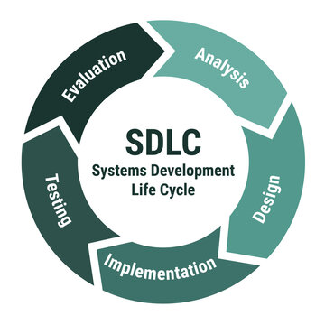

A typical software development life cycle consists of the following stages :-

## Stage 1 : Planning and Requirement analysis

Requirement analysis the most important and fundamental stage in SDLC. It is performed by the senior members of the team with inputs from the customers, the sales department, market surveys and domain experts in the industry. This information is then used to plan the basic project approach and to conduct product feasibility study in the economical, operational and technical areas

Planning for the quality assurance with the project is also done in the planning stage. The outcome of the technical feasibility study is to define the various technical approaches that can be followed to implement the project successfully with minimum risk.

## Stage 2 : Defining requirements

Once the requirement analysis is done the next step to clearly and document which consists of all the products requirements to be designed and developed during the project life cycle.

## Stage 3 : Designing the project Architecture

SRS is the reference for product architects to come out with the best architecture for the product to be developed. Based on the requirement specified in SRS, usually more than one design approach for the product architecture is proposed and documented in a DDS - Design document specification.

This DDS is reviewed by all the important stakeholders and based on various parameters as risk assessment, product robustness, design modularity, budget and time constraints, the best design approach is selected for the product.

A design approach clearly defines all the architecture modules and third party modules ( It any ). the internal design of all the modules of the proposed architecture should bee clearly defines with the mInutest of the details in DDS

## Stage 4 : Buliding or developing the product

In this stage the actual development starts and the product is build. The programming code is generated as per DDS during this stage. If the design is performed in A detailed and organized manner, code generation can be accomplished without much hassle.

Developers must follow the coding guidelines defines by their organization and programming tools like compilers, interpreters, debuggers, high level programming language is chosen with respect to the type of software being developed.

## 